|  |  |  |
| --- | --- | --- |
|  | **Physics Workbook 1** | |
|  |  |

Name: _____________________________

Due: _______________________________

|  |  |  |
| --- | --- | --- |
|  | **Velocity-Time Graphs** | |
| **Date:** | **Name:** |

The velocity-time graph is even more useful than the displacement-time graph.

For all velocity-time graphs, time is the independent variable (along the horizontal axis) and velocity is the dependent variable (along the vertical axis).

For a velocity-time graph there are only three skills needed to properly analyze the graph:

1. Reading values off the graph.
2. Finding the slope of the graph.
3. Finding the area underneath the graph.

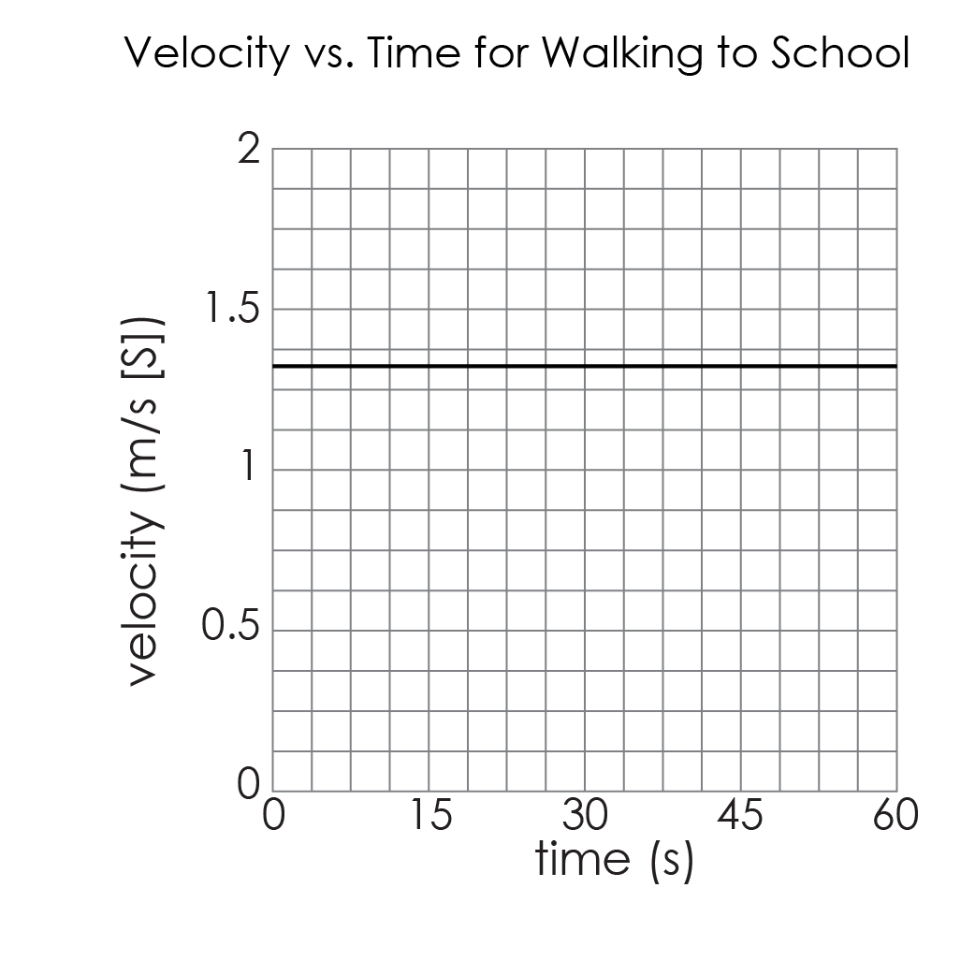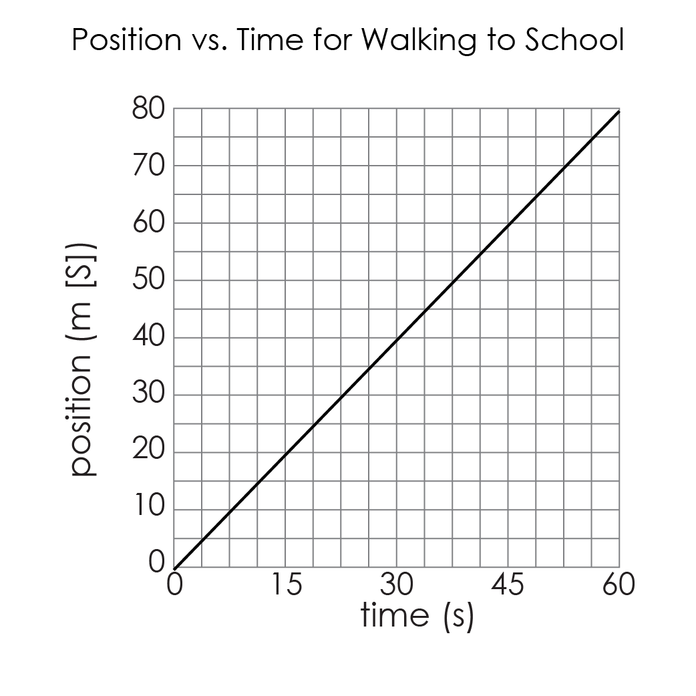The two graphs below represent the same situation: a student walking to school, 80 m [S] from home, at a constant velocity of 1.33 m/s [S].

Examine the two graphs for similarities and differences.

|  |  |
| --- | --- |
| **Similarities** | **Differences** |
|  |  |

You may recall finding the slope of this position-time graph in a previous lesson. The slope of the position-time graph was 1.33 m/s [S] – the same as the reading on the velocity-time graph.

Determine the slope of the velocity-time graph. _______________________

The value is easy to see, but what are the units of the slope of a velocity-time graph?

Therefore, the slope of a velocity-time graph gives the _______________________________.

For the velocity-time graph, find the area underneath the line (between the line and the time-axis). Examine the units.

Therefore, the area under the graph of a velocity-time graph gives the

_______________________________.

Summary: For a velocity-time graph

|  |  |  |
| --- | --- | --- |
| Reading the graph | Finding the slope | Finding the area |
|  |  |  |

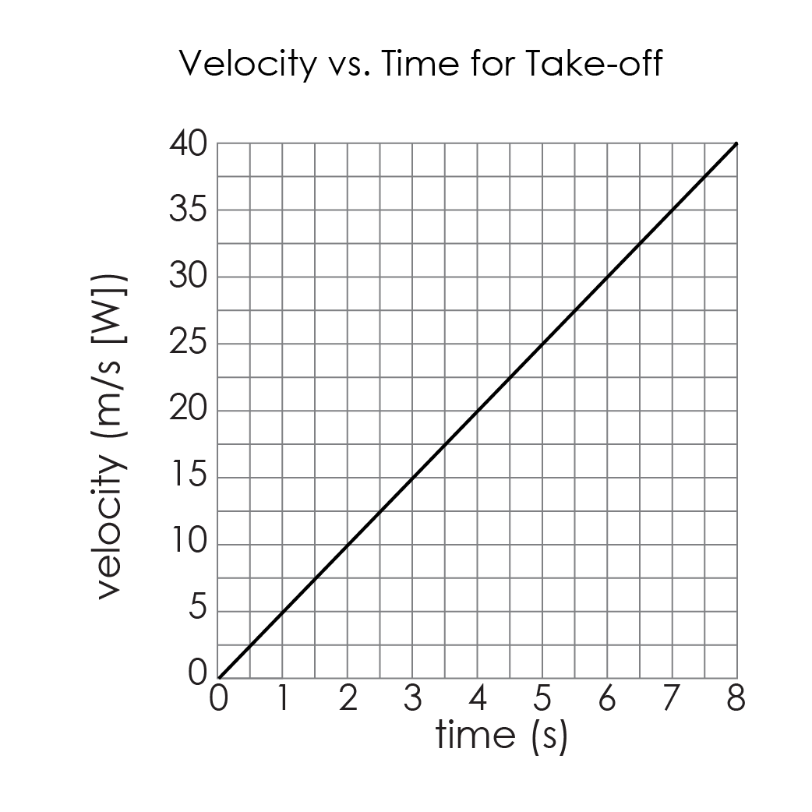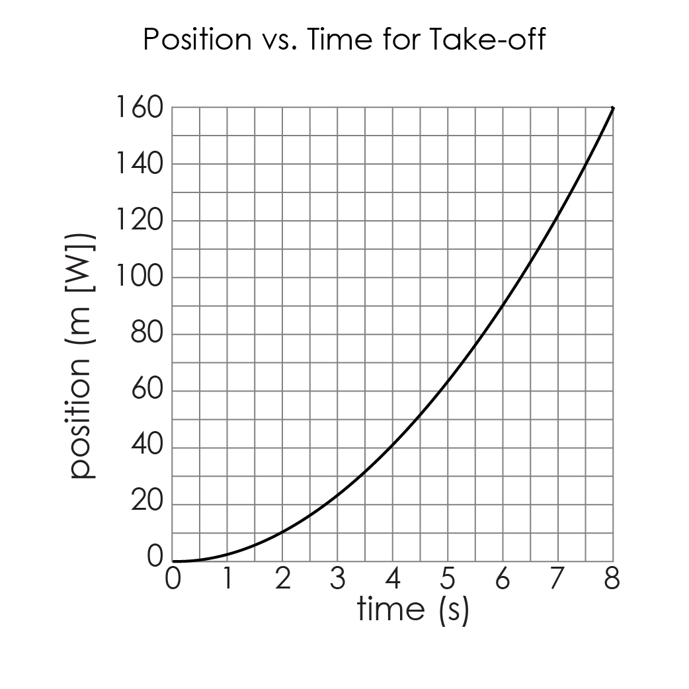Velocity-time graphs are more interesting during acceleration.

Displacement (m)

Both the position-time graph and the velocity-time graph above model the same situation: a plane taking off on a runway. Earlier we found the position of the plane by reading the position-time graph and found the instantaneous velocity by finding the slope of a tangent line.

|  |  |
| --- | --- |
| Find the position of the plane after 5 seconds. | |
| Use the displacement-time graph. | Use the velocity-time graph. |
| Find the instantaneous velocity at t = 7 seconds. | |
| Use the displacement-time graph. | Use the velocity-time graph. |

Both position-time graphs and velocity-time graphs can be used to easily find position and velocity. Acceleration can easily be found from the velocity-time graph. In this case, the velocity-time graph is linear, that means acceleration is ____________________.

Find the acceleration of the plane using the velocity-time graph.

Velocity-time graphs can be used to create position-time graphs and vice-versa. We will do a complete analysis of this velocity-time graph, then use that information to create a position-time graph.

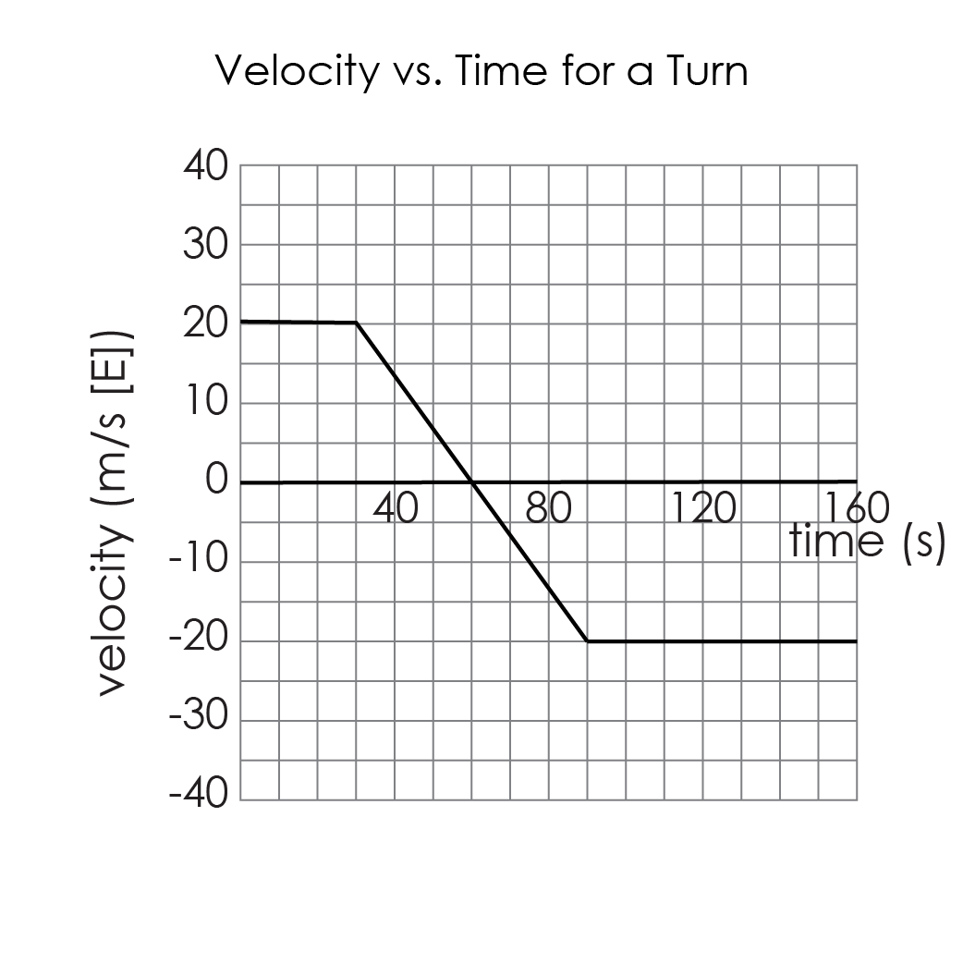

Examine the graph. Describe the motion (and use the title as a hint).

|  |  |  |  |  |  |  |  |
| --- | --- | --- | --- | --- | --- | --- | --- |
| Determine the velocity of the object after: | | | | | | | |
| 10 s | 20 s | 30 s | 40 s | 50 s | 60 s | 70 s | 80 s |
| 90 s | 100 s | 110 s | 120 s | 130 s | 140 s | 150 s | 160 s |



What is the acceleration of the object between 0 s and 30 s?

What is the acceleration of the object between 30 s and 90 s?

What is the acceleration of the

object between 90 s and 160 s?

What is the significance of

the point (60, 0)?

To determine the position, find the area between the graph and the time-axis *up to that point*.



It is often easier to find the areas of the different sections of the graphs, then add them together afterwards. This graph can be broken into 4 sections. Note the area is “negative” underneath the time axis.

Use the areas to determine the position of the object after:

|  |
| --- |
| 30 s |
| 60 s |
| 90 s |
| 160 s |

Use the upper and lower bounds of the position as a guide for determining a scale for the position time graph. Label key positions (at times 30, 60, 90 and 160 seconds. Then consider the shape of the position-time graph, given the motion in those sections - should you use straight lines, or parabolas?

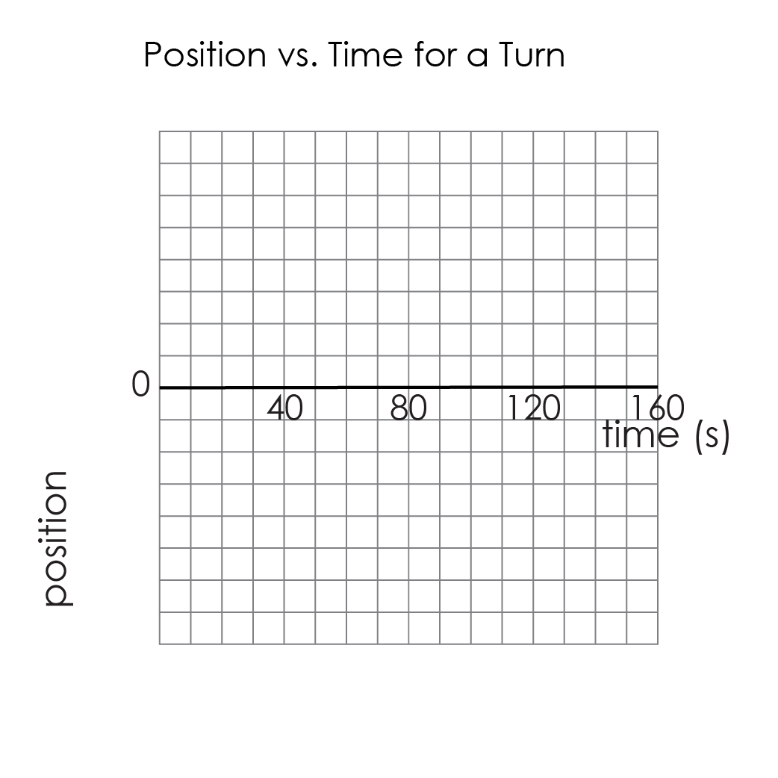

**Velocity-Time Graph Summary**

|  |  |
| --- | --- |
| **Key Terms** | **Equations** |
|  |  |
| Describe, with the aid of diagrams, how the slope of a velocity-time graph relates to the acceleration. Include horizontal lines and lines with negative slope. | |

**Practice Questions**

|  |  |  |  |  |  |
| --- | --- | --- | --- | --- | --- |
| Q1. Examine the graph for an athlete using high-intensity interval training (HIIT).  a) Describe the motion of the athlete using values from the graph. | | | | | |
| b) During which time interval(s) does the athlete have a constant velocity? | | | c) During which time interval(s) does the athlete have a constant acceleration? | | |
| d) Determine the different accelerations for the time intervals identified in part c. | | | | | |
| e) Section the graph into shapes, then find each shape’s area. | | | | | |
| f) Find the position of the athlete after | | | | | |
| 0 s | 5 s | 15 s | 17.5 s | 35 s | 40 s |
| g) Use the information from the previous questions to create an accurate displacment-time graph for the athlete. | | | | | |

|  |  |  |
| --- | --- | --- |
|  | **Comparing Graphs** | |
| **Date:** | **Name:** |

Sketch the shape of each type of graph, then draw a diagram to represent that type of motion.

|  |  |  |  |
| --- | --- | --- | --- |
|  | **Displacement -time graph** | **Velocity-time graph** | **Diagram** |
| Stopped |  |  |  |
|  |  |  |
| Constant velocity |  |  |  |
|  |  |  |
| Speeding up |  |  |  |
|  |  |  |
| Slowing down |  |  |  |
|  |  |  |

**Practice Questions**

|  |  |
| --- | --- |
| Sketch a graph for each of the following situations. | |
| Q1. A car waits at a red light for 12 seconds, then accelerates North at a constant rate up to a 16 m/s over 4 seconds. The car maintains that constant velocity for 15 seconds. | |
| distance-time graph | Velocity-time graph |
| Q2. An ambulance is travelling at a constant velocity of 14 m/s [E]. After a short time, the ambulance driver receives a message to attend to an emergency. The ambulance quickly decelerates to a stop, turns around and accelerates to 22 m/s [W]. | |
| Displacement-time graph | Velocity-time graph |
| Q3. A dog plays fetch: the dog accelerates towards a ball, decelerates to a stop to retrieve the ball, then accelerates back towards its owner and decelerates to a stop as it reaches its owner. | |
| Displacment-time graph | Velocity-time graph |

|  |  |  |
| --- | --- | --- |
|  | **Graphing Acceleration** | |
| **Date:** | **Name:** |

In this task, you will need to compare motion in terms of displacement, velocity and acceleration.

1 Figure 1 shows the change in position of a stray cat as it runs down a straight laneway.

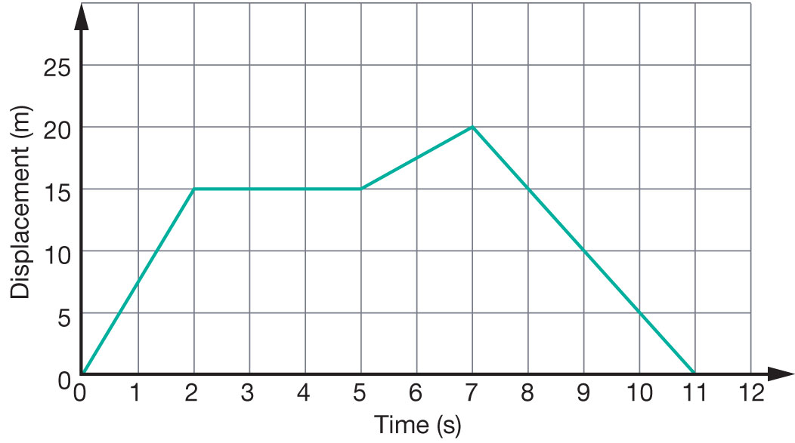

Figure 1

Displacement graph of a cat running down a laneway.

a Use Figure 1 to **construct** a velocity–time graph of the cat’s motion on the axis on the following page.

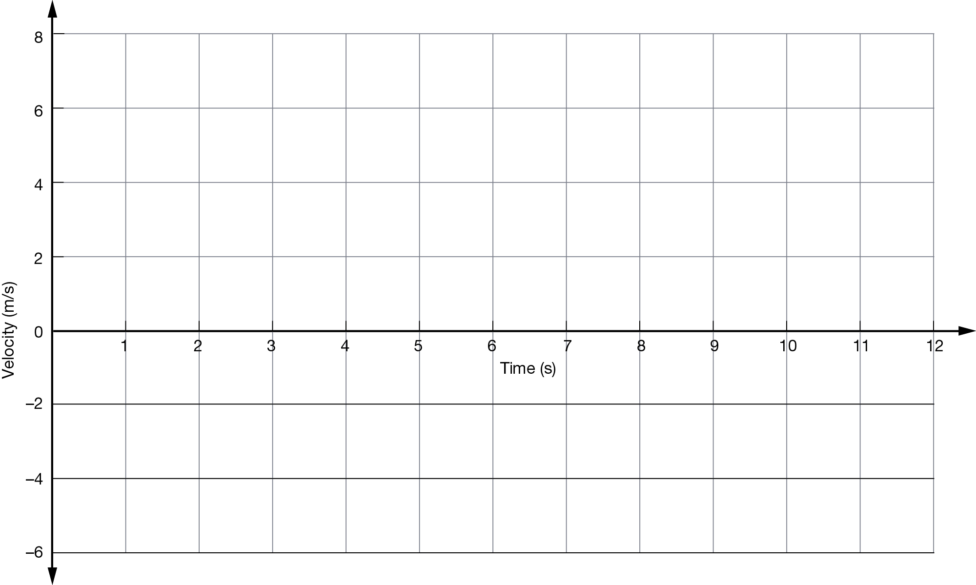

b **Describe** the motion of the cat as it runs along the laneway.

2 Figure 2 shows the motion of a cruise ship as it travels in a straight line route from the docks to its destination.

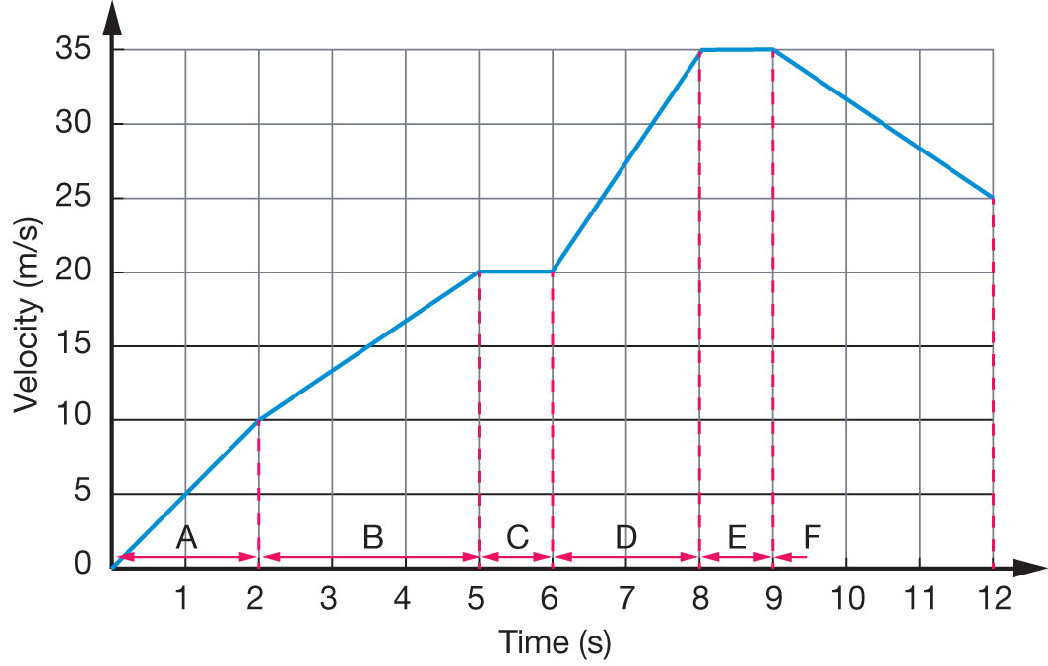

Figure 2

Motion of a cruise ship.

a Calculate the average acceleration of the ship in each of the sections marked A–F. Fill out your results in the table:

|  |  |
| --- | --- |
| Section of motion | Average acceleration (m/s/s) |
| A |  |
| B |  |
| C |  |
| D |  |
| E |  |
| F |  |

b Use your results from part a to construct an acceleration–time graph of the ship’s motion on the axes below:

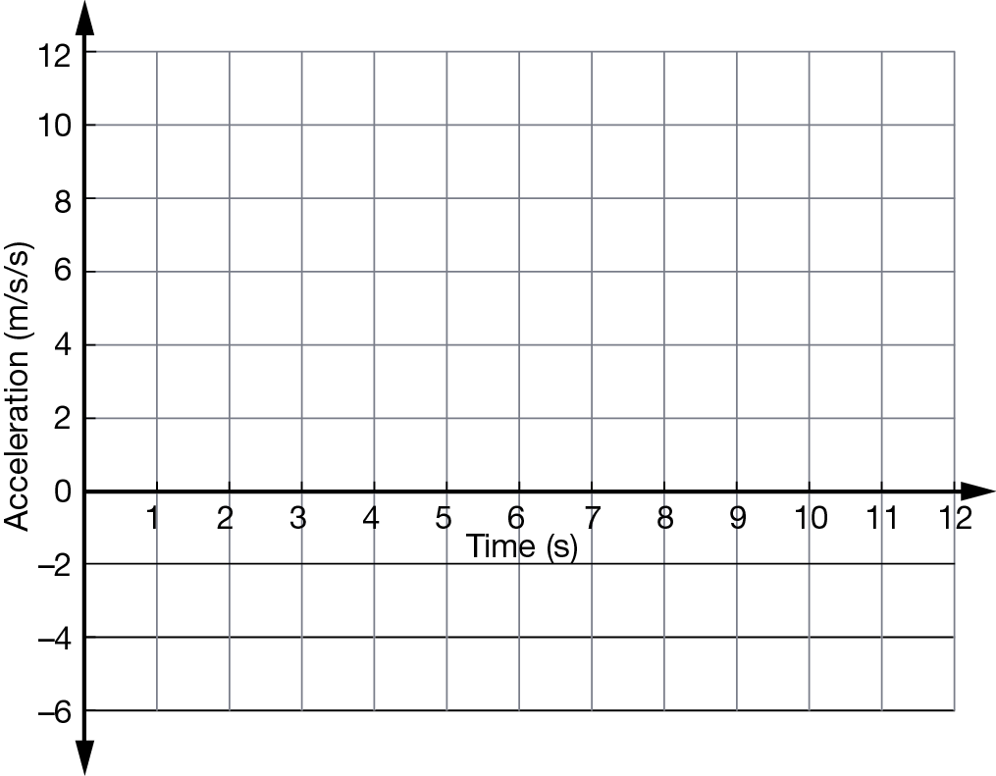

c Identify in which sections the ship is:

i speeding up:

ii slowing down:

iii travelling at a constant speed:

d Calculate the distance the ship sails in the first 5 seconds of its journey.